**MR Chaining Use case**

**Input**: Student.txt

**Code**: Driver.java, MyMapper.java, MyReducer.java, MyMapper1.java, MyReducer1.java

**Jar file**: Chaining.jar

**Package**: com.mapred.chaining

**Commands**: cp /home/mrinmoy/Downloads/MapReduce/Chaining.jar .

cp /home/mrinmoy/Downloads/MapReduce/Student.txt .

hadoop fs –mkdir /Chain50

hadoop fs –put Student.txt /Chain50

jar –xvf Chaining.jar

hadoop jar Chaining.jar com/mapred/chaining/Driver /Chain50/* /ChainOut50

hadoop fs –cat /ChainOut50/part-00000

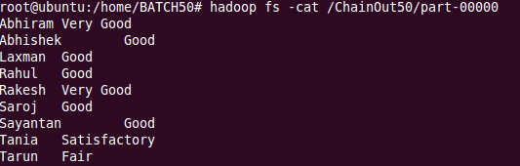

hadoop fs –cat /user/job1out/part-00000

